**YourSQL: A relational database tool for pedagogical purposes**

**User Guide**

This document provides a brief description of YourSQL’s functionality and a guide that will navigate you through the interface. A brief overview will be presented using screenshots to help you familiarize with the tool.

YourSQL is a relational database tool used for teaching relational algebra and SQL language and help the learner understand how these topics are associated. The system intends to provide the users an interactive approach to utilize their knowledge of the theoretical aspects of these topics and a practical approach to familiarize with their operations. Moreover, provides means for query optimization to help the user conceptualize the importance its importance in performance.

# **Brief overview**

The user submits a SQL statement that is converted into a canonical tree that is built using relational algebra operations and the corresponding optimized tree. Additionally, the intermediate results of every execution step are available to allow comparison between the execution process.

# **Let’s get started!**

You can start YourSQL, by double clicking on the Java executable application named “YourSQL” that is displayed with the icon . The application is runnable on any host with Java version 8 installed.

# **Application Components**

Once the application is running the main window shown in Figure 1 is displayed. As we can see the screen is divided into three major parts. The leftmost panel, the Canonical Tree Panel”, will be displaying the Canonical tree that translates the SQL query into relational algebra operations and the rightmost panel, the “Optimized Tree Panel”. This component will display the optimized tree, that will be composed after we apply the optimization algorithm to the canonical tree. Notice that for SQL statements that contain the “OR” operator, there will be no optimized tree and instead a message that notifies the user will be displayed. Finally, the third component of the GUI is the “Output Panel. The resulting relation of every query execution will be displayed in the form of a table. Also, through this component any error messages and notifications that arise based on the user’s actions are presented.



*Figure 1 Application main window*

# **Loading a database File**

The first step that the user must take when using this tool is to load the database file that the system will be connected to in order to perform the queries. This functionality is provided through the menu bar (Figure 1). The process of loading the database file is:

1. Click on: File ⇨ Load Database
2. From the dialog box (Figure2) navigate through the directories to find the database file you wish to load and click on it.
3. Click on: Open

As illustrated in Figure 2, only files with the extension “.db” are available to be selected.

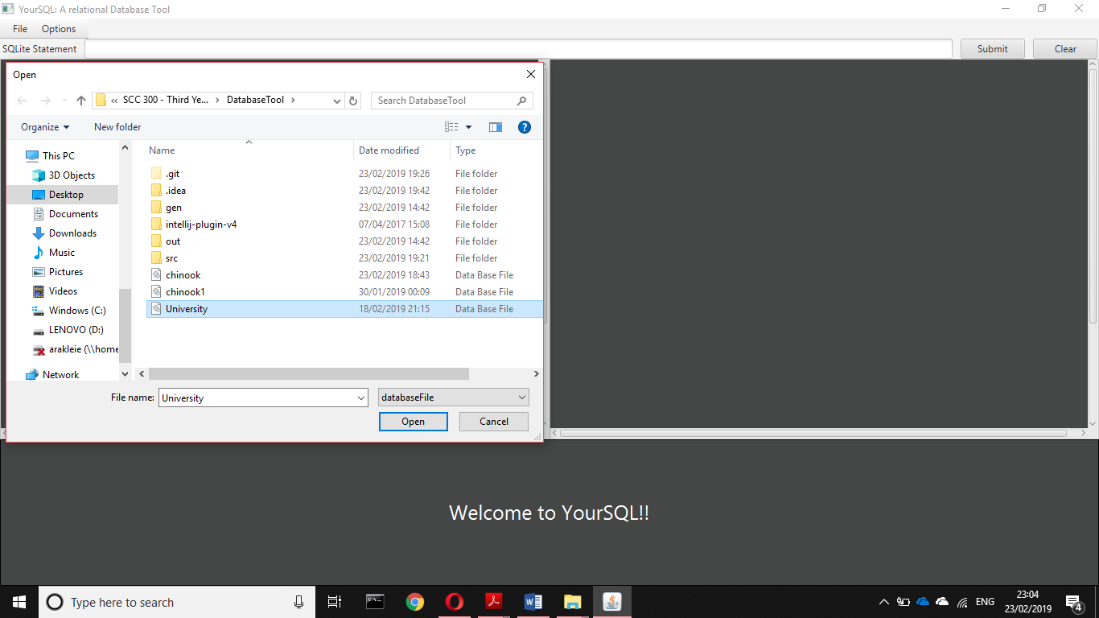

Figure 2 Screenshot presenting dialog box for loading the database file

# **Query Execution**

Once the database file is loaded the user will be notified and he/she will be able to perform operations on the database. This system supports only two types of SQL statements, the simple “SELECT” and the “DROP TABLE”. This section will provide an overview of the query execution process through an example and screenshots from the actual results of every step will be provided for further assistance. For this example, the following statement will be executed:

SELECT courses.c_id , department.d_id ,give_course.c_id , give_course.s_id

FROM courses, department, give_course

WHERE courses.d_id = department.d_id and courses.c_id = give_course.c_id and department.d_title = "Computing" and department.d_id = "COMP";

The user must type the statement to the text box provided and press the “Submit” button (Figure3). Thereupon, the canonical tree will be displayed into the leftmost pane and the optimized tree will appear the rightmost pane. This functionality is illustrated in Figure 4. Notice that sometimes the optimized and the canonical tree may be identical.

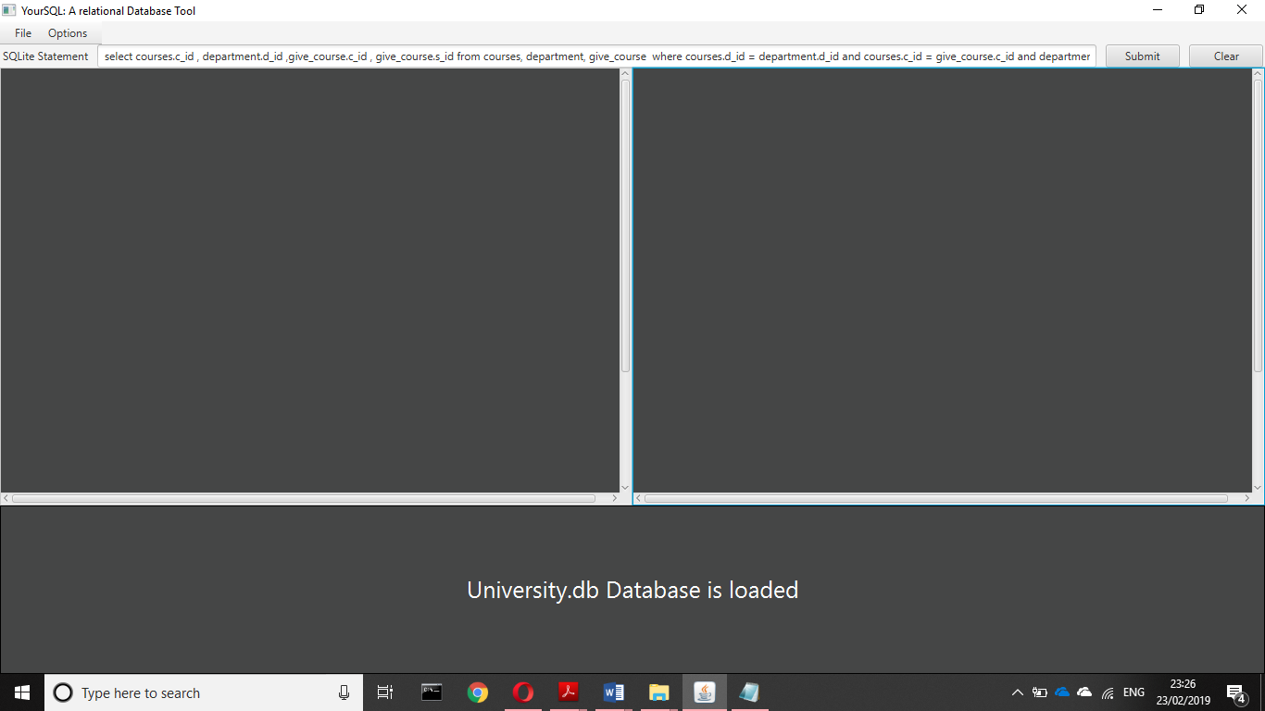

Figure 3 Screenshot for adding the statement into the text box and guidance for the submit button.

Figure 4 represents the state that the system will be in after the execution of the statement. The canonical and optimized trees are presented in the left and right panel respectively and the results are presented in the output pane. Each node in the tree is represented by a button. The user can see the full content of the button by hovering over (Figure 4).

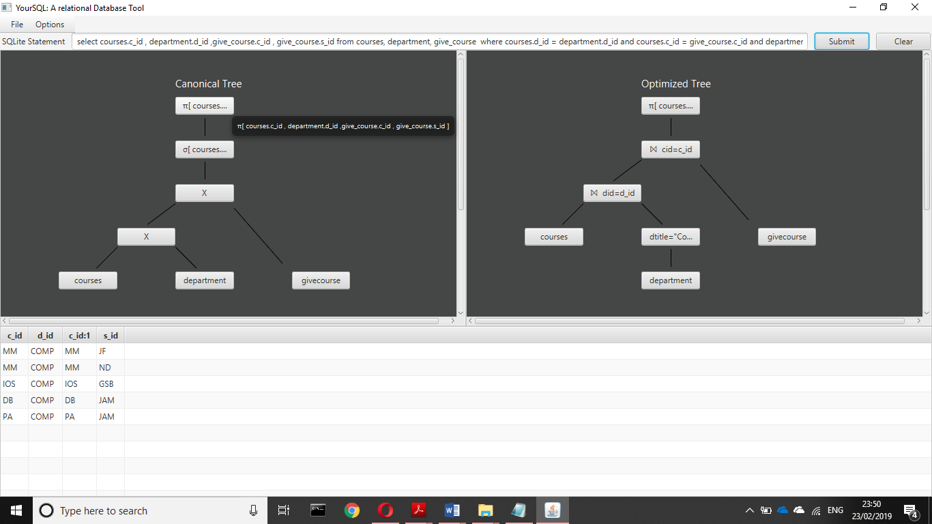

Figure 4 GUI after submitting a statement

The query execution is performed starting from the leaf nodes and moves upwards. The system provides the records of each resulting relation at every execution step. This feature is available for both the canonical and the optimized tree. The user can choose to view the results by clicking the node from the tree that he/she wish to view, and a new window will open containing a table with the records (Figure 5). The user can have multiple windows open to allow comparison between the results of different execution steps.

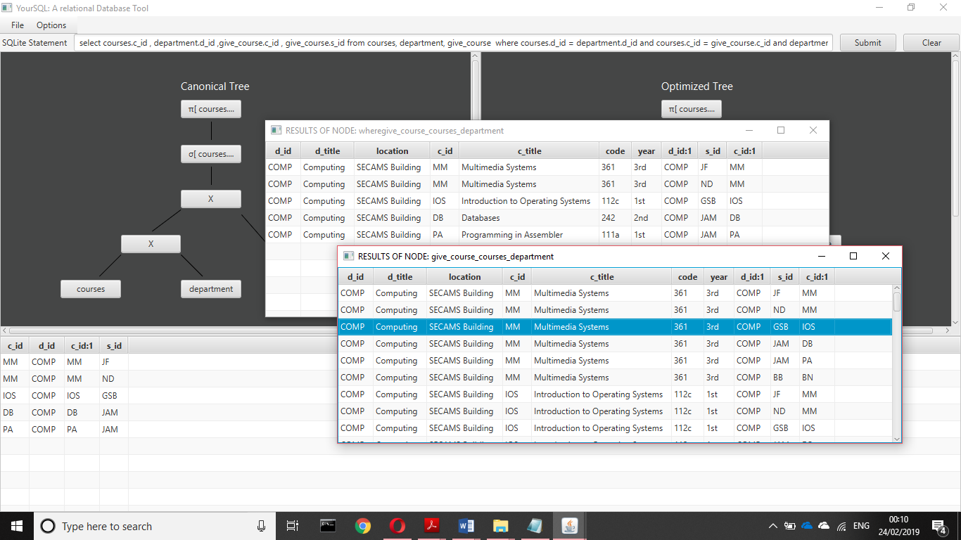

Figure 5 Screenshot with window that represent the results of 2 different execution step

The user can compare the two trees and view the results after every execution to comprehend the concepts of relational algebra and what steps the execution algorithm goes through for executing the statement. The user can submit a new query by typing it in the statement text box. Furthermore, the user can clear the stage by clicking the “Clear” button that appears right after the “Submit” button (Figure 6).

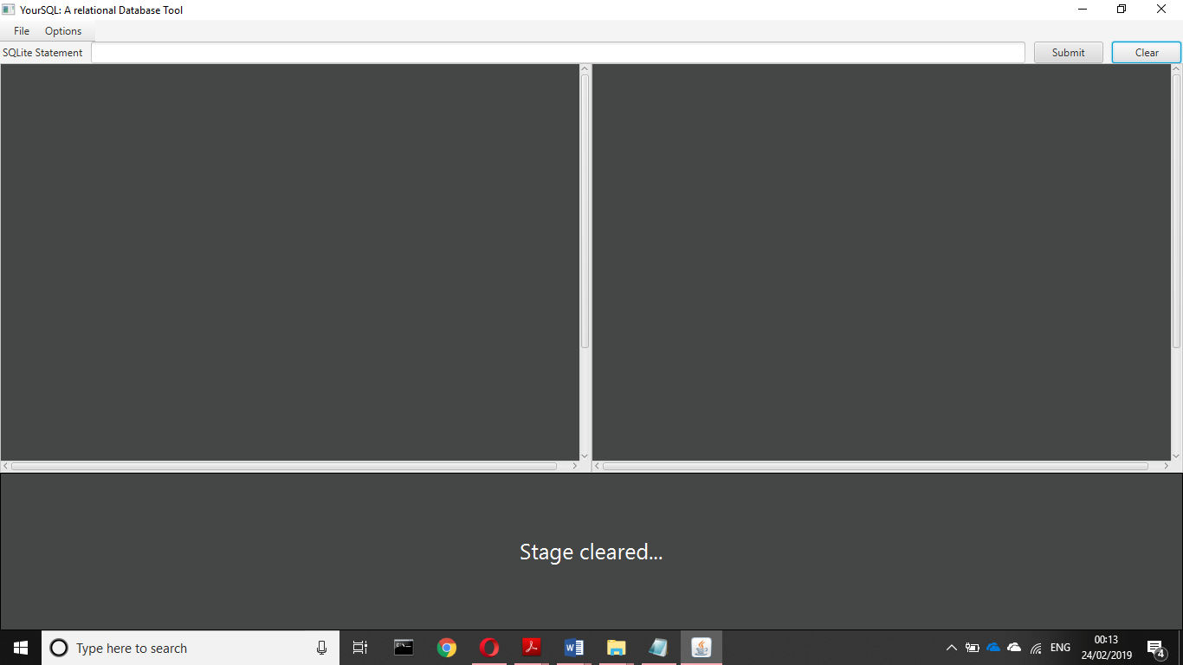

Figure 6 Stage after the user clears the stage

# **Query Files**

For convenience YourSQL implements an additional functionality. When the user loads the database, the system looks into the directory that the database file is stored for a text file of name “databaseNameQueries”. If the system discovers a file, it loads the contents to the system and the user can choose to view the queries from that file. Although, there are a few restrictions on how the file should be formatted:

* The file name must be the name of the database loaded appended with the word “Queries”. e.g., if database name is students then the file must be named “studentsQueries”.
* Each query in the file must be written in a separate line.

Consequently, if a user is executing the same statement multiple times, he/she can type it once into the file and then use the “Query Panel “to execute it again.The process to view and execute a query from the query list is performed by following these steps:

View and execute queries:

1. Click on: Option ⇨ View Queries
2. From the query panel (Figure 7) double click on one of the list items.
3. The query will be copied into the input field. Press submit to execute it (Figure 8)

The option “Hide Queries” is disabled when there are no Queries displayed yet (Figure 7).

# Right Pointing Backhand Index

Figure 7 Screenshot to navigate the user to view the queries

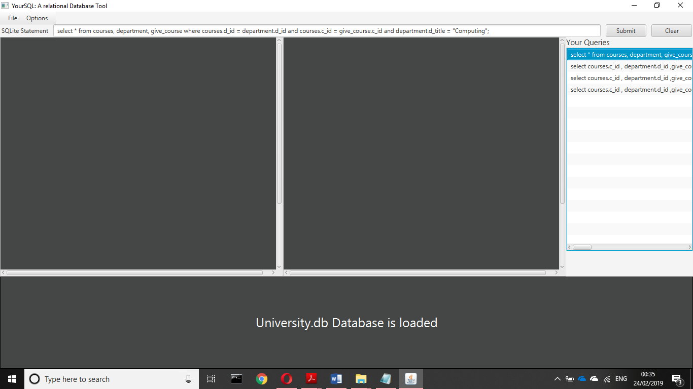

Query Panel

Figure 8 Screenshot that illustrates the queries after the user requests to view them

The user can choose to hide the queries by clicking on “Options” and then on “Hide Queries”. As before the “View Queries” option will be disable as the queries are already displayed.

# **Database State**

YourSQL can keep track of the database state and allows the user to save the state or restore the previous version. From the menu bar the user can click in either “Reset Database” or “Save Database”. This functionality is illustrated in Figure 9 and 10 respectively. The “Save” option will save the changes made so far to the database and reset option will retrieve the version of the database up to the last save. If the user has not saved the database yet, then the database loaded will be retrieved again.

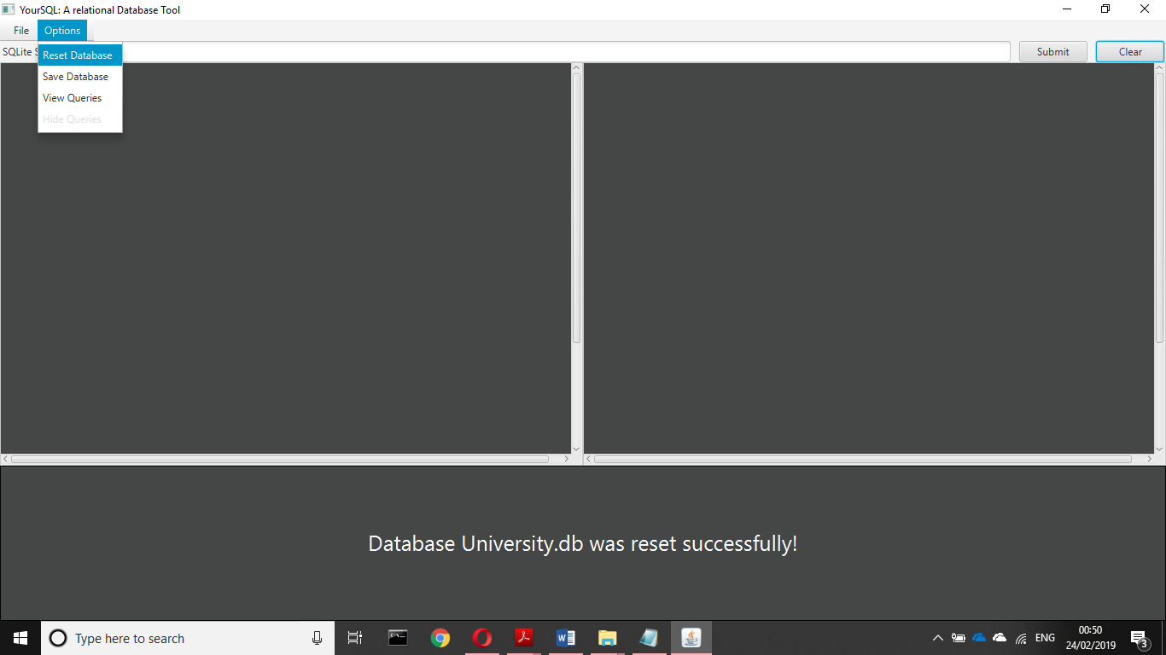

Figure 9 Example of resetting the state of a database

# **Close the application**

Once the user is finished, he can close the application by clicking the 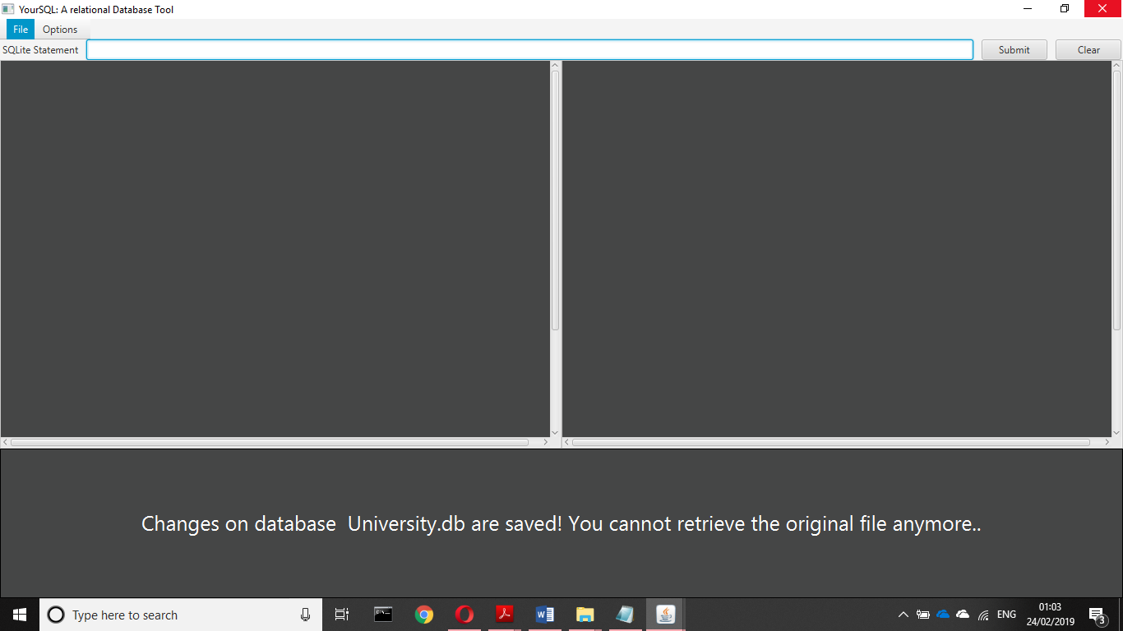 icon at the top right of the screen or by clicking “File” ⇨ “Close” from the menu bar. In both cases a dialog window will open allowing the user to return to the application, save the database or exit without saving by pressing “Cancel”, “Save” or “Don’t save” respectively (Figure 10).

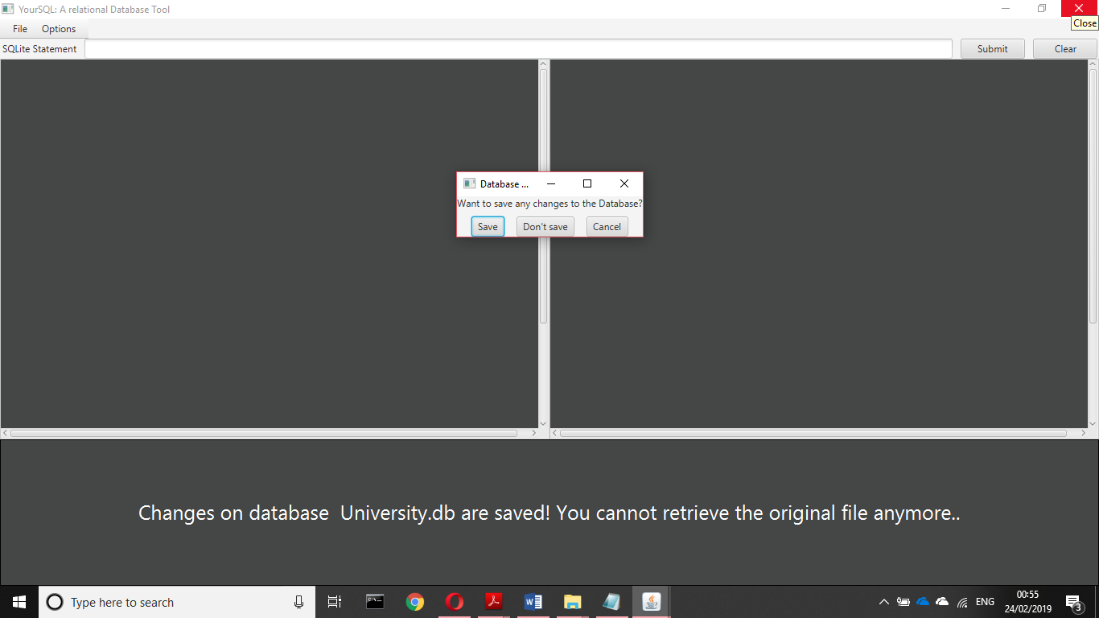

Figure 10 Screenshot for closing the application

# **Error Messages**

This section will describe the error messages produced by YourSQL upon user interaction.